DRENCHED IN THE DUNES – Zandvoort - 24, 25 August 2002

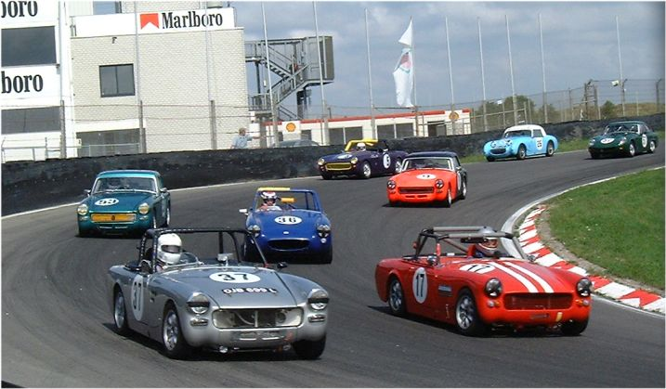

Zandvoort hosted rounds 6 and 7 of the FISC – European AH Sprite and MG Midget Competitions. As last year, this beautiful circuit nestling in the dunes of the West Coast of Holland provided fast, clean racing and variable weather.

Free practice Friday took place in beautiful sunshine. However, qualifying Saturday morning was wet. John Faux (GB) took pole position in a time of 2.37.5, a clear two seconds ahead of Antonio Bertini (I) with guest driver Andrew McGee (GB) third on the road and Ian Hulett (GB) in FISC third.

Race 1 – Tyre choice was causing a lot of heartache. From the paddock the circuit appeared wet so many of the field retained their wet tyres following qualifying, whilst others had gambled on a drying circuit and fitted their dry tyres. As the cars left on their formation lap it became very clear to all drivers that a very dry line was evident. Pole man Faux led the field round for the rolling start – a steady pace, the lights turned green and race one was underway. John Faux kept his advantage and started to pull away with Andrew McGee, both running full dry tyres, from Antonio Bertini, Pieter Bakker (NL) and Richard Evans (GB) who had made a brilliant start from ninth on the grid. Unfortunately it would all go horribly wrong at Nissanbocht where the silver number 37 outfit could be found deep in the gravel trap. On lap three the rain started to fall in monsoon proportions. Pieter Bakker’s race ended at Bosuit. Local Dutch driver Mark Dols (NL) managed to work his way into FISC second place and was catching Faux and McGee until the atrocious conditions ended his charge on the exit of Mitsubishibocht. With two laps to go the rainmeister, Ian Whitt (GB) hit the front to take a well-earned win from John Faux and Antonio Bertini. Andrew McGee ending in seventh after seeing the initial advantage of his dry race tyres start to work against him in the torrential conditions.

Race 2 – Sunday hot and sunny. With only the one qualifying session for two races the grid positions were as the first race, John Faux once again at the front. A more even pace this time for the pack. However Antonio Bertini took the early lead from John Faux, Ian Hulett, Andrew McGee and Pieter Bakker. The second group of some eight cars was led by Mark Dols and were fighting for every inch of tarmac. At one point four cars appeared over the horizon into Nissanbocht side by side – no quarter asked or given – and no paint traded as they made it through. Fantastic racing from start to finish throughout the field. Ian Hulett took the win from John Faux and Andrew McGee with in FISC third Pieter Bakker in another memorable race at this fantastic circuit, Zandvoort.

Results: Race 1: 1 Ian Whitt (GB) 2 John Faux (GB) 3. Antonio Bertini (I).
Race 2: 1 Ian Hulett (GB) 2 John Faux (GB) 3. Pieter Bakker (NL).

Andrew McGee reported “Being welcomed into the series as a guest driver with a car that isn’t 100% eligible is certainly refreshing. To experience good clean racing at some of the best European Circuits along with the best hospitality and catering package that club level competitors can entertain is unprecedented”.

For information on the FISC European Spridget Competitions and next years calender, please visit the FISC website at www.fisc-racing.com.

